HTML/CSS Day 5 Knowledge Test

  - What tag is used for external links? (write out the complete tag with any attributes)

  - What tag creates list with a predefined style of bullet points?

  - Write out the main HTML tags that make up the skeleton of every website.

  - What is the purpose of the head tag?

  - What area of the HTML page should you link in your CSS?

  - How are websites made responsive?

  - What is the selector used in CSS to embed/declare custom fonts?

  - What is the purpose of a webkit?

  - Name all the webkit variations and the browsers that they support.

  - Name a benefit of using the Mobile first development approach?

  - What part of the systems development lifecycle (SDLC) have we been practicing for most of this week?

  - What is the next stage after the analysis stage in the SDLC?

  - What does HTML stand for?

  - What does CSS stand for?

  - Write an example of a pseudo selector.

  - Explain how the CSS position attributes relative and absolute can be used together.

  - How can I access the li elements within CSS?

<nav>

<ul >
<li><a href="#home">Home</a></li>
<li><a href="#products">Products</a></li>
<li><a href="#products">Products</a></li>
</ul>
</nav>

Part 2

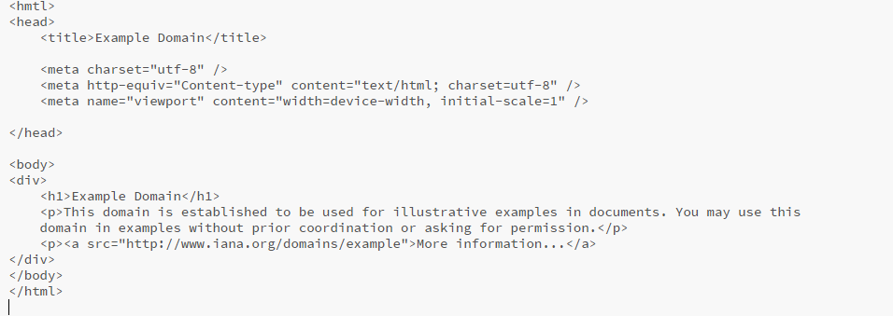
- Spot the errors in the following code.

- There are approximately 3-4

- What 3 languages make up the web development trifecta?

- What tag ensures that text is displayed as bold/important in HTML?

- Which of the following indicates an end tag?
- / * < @ “ !

- Write the required HTML code that would insert an image.

Part 3

- How is a comment written in CSS?

- What declaration allows you to change the color of the background?

- Name a class selector and an ID selector.

- What is the default attribute for the position property?

- Write the following with the correct naming convention –

Class=” test class”

